**K3**

**Series**

**RF Module Specification**

**Document modification history**

|  |  |  |
| --- | --- | --- |
| **Version** | **Description** | **Date** |
| V1.0 | Create | 2015-5-1 |
| V1.1 | Optimizing Content | 2016-6-10 |
| V1.2 | Revise | 2017-5-17 |

Catalogue

**Catalogue**

Chapter I Product overview 3

1.1 Summary 3

1.2 Characteristic 3

1.3 Appearance and interface diagram 5

Chapter II List of basic functions 6

Chapter III PCB size and interface layout 8

3.1 Interface parameter description 8

Chapter IV Precautions for assembly use 9

**Chapter I Product overview**

## Summary

The M2 module is a 13.56MHZ high-frequency read-write module. The module has its own CPU control, which does not require secondary programming. The complete serial port transceiver can be seamlessly connected with any system without loading any driver. The integrated on-board RF antenna has more stable performance, and is very suitable for charging piles, self-service sales, and advertising machines.

## Characteristic

* + - The module is small, easy to install, widely used and easy to develop.
    - The built-in CPU control does not require the user to edit the program twice, and the IC card can be easily operated through the serial port protocol.
    - Full serial port control, seamless connection with any system, no need to install additional drivers, just connect VCC, TX, RX, GND four wires to communicate.
    - Ultra wide voltage (3.3V/5V/9V) is optional, and 5V power supply is used as standard configuration, which can meet the output voltage of most serial ports of development boards.
    - Humanized design, the buzzer can be controlled as a reminder action, and the on-board power LED light is convenient to check the power on status
    - It has complete functions, clear development protocols, supports IC card read and write operations, sector encryption, and the CPU can store 50 characters as flash backup data.
    - Support mode switching, read-only or read-write mode setting, and three output formats can be switched in read-only mode.

## Appearance and interface diagram

Front/Back：

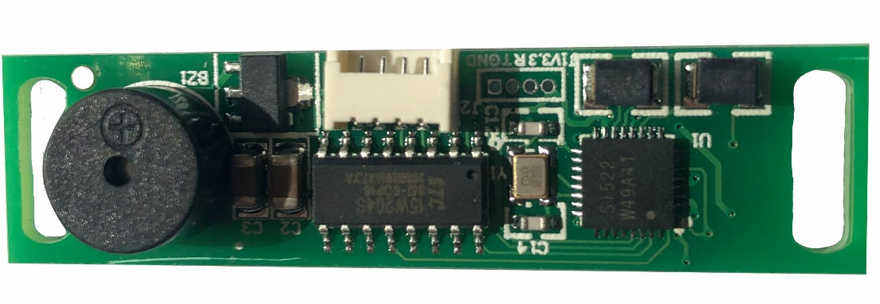

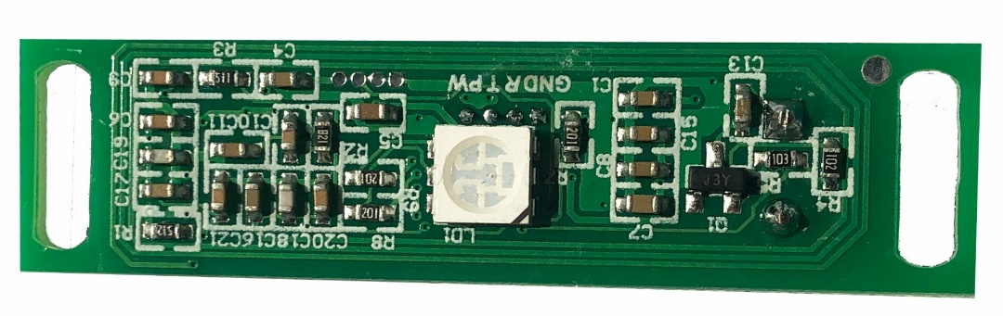

# Chapter II List of basic functions

|  |  |
| --- | --- |
| **Main technical parameters** | |
| Support Agreement | ISO14443A |
| Support  Card | Mifare（1K/4K）；NXP S50,NXP S70，复旦微 F08，Ultralight |
| Operating System | Windows98、XP、Win7、8、ME、2003、VISTA、LIUNX、UNIX、Android |
| Card Reading Distance | 00~60mm |
| Card Reading Time | ＜100ms |
| Communication Rate | 9600 |
| RF Antenna | Integrated with PCB |
| Communication Interface | Uart TTL |
| Working Voltage | Standard 5V |
| Operating Current | 60mA |
| Working Frequency | 13.56MHZ |
| Work Environment | Temperature（-20℃~85℃） Humidity（5%~95%） |
| Indicator Light | LED |
| Built In Horn | Controllable Buzzer |
| Other Interfaces |  |
| Product Size | 40mm×11mm； Thickness 1.2mm |

**Chapter III PCB size and interface layout**

* 1. **Interface parameter description**
* **Power input interface**

The 5V DC power supply is adopted, and only **the computer or development board** is allowed to supply power to the board subsystem. In the case of no external empty load, the 9V DC power supply needs to support a minimum current of 100mA.

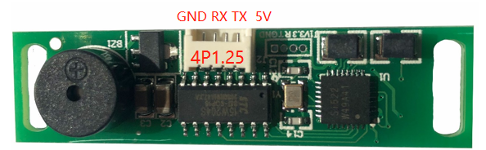

The interface of the power socket is defined as follows. The power can be supplied by the main control board. The specification of the seat is 4PIN 1.25mm.

|  |  |  |  |
| --- | --- | --- | --- |
| **The serial number** | **Definition** | **Attribute** | **Description** |
| 1 | GND | Ground Wire | Ground Wire |
| 2 | --- | --- | --- |
| 3 | --- | --- | --- |
| 4 | VCC | Power Supply | 5V Input |

# Chapter IV Precautions for assembly use

Please pay attention to the following (but not limited to) problems during assembly and use.

I. Short circuit between bare board and peripherals.

II. During the installation and fixation, avoid the deformation of the bare plate due to the fixation.

III. When installing the serial port, pay attention to whether the USB device is directly connected. Whether the TX and RX connections are correct.

IV. Whether the input power supply is connected to the power input interface, and whether the input power supply voltage and current meet the requirements according to the evaluation of the general peripherals.

V. If the card is not read, whether the card that is not supported by this product is used or swiped in a critical state, or whether the card is damaged.

VI. When selecting 232 interface, the control board with 232 chip should be correctly connected to avoid data garbled when connecting 232 with TTL

VII. Pay attention to the direction of VCC and GND to avoid PCB burning after reverse connection.